Chapter 5, Solution 78.

The circuit is constructed as shown below. We insert a VIEWPOINT to display v_{o}. Upon simulating the circuit, we obtain,

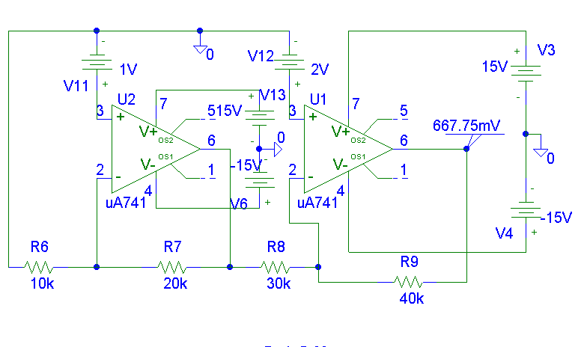
v_{o} = 667.75 mV

